Hotel Booking Analysis
Yusuf Khan,
Sameer Awasthi
Full Stack Data Science Aspirants,
AlmaBetter, Bangalore

Abstract:
This project includes a record of actual hotel reservations for a city and a resort hotel. It includes information on reservations, cancellations, and guest information. The project's primary goal is to comprehend and display data from the perspectives of hotels and customers.
We will perform exploratory data analysis with python to get insight from the data.

Keywords: Hotel Booking Resort Hotels, City Hotels
1. Problem Statement
This data set contains booking information for a city hotel and a resort hotel, and includes information such as when the booking was made, length of stay, the number of adults, children, and/or babies, and the number of available parking spaces, among other things. All personally identifying information has been removed from the data.
Now, we have to:
“Explore and analyze the data to discover important factors that govern the bookings.”

2. Introduction

In this project, we will try to figure out the following questions:
- How Many Booking Were Cancelled?
- What is the booking ratio between Resort Hotel and City Hotel?
- Which is the busiest month for hotels?
- From which country most guests come?
- How Long People Stay in the hotel?
- Which was the most booked accommodation type (Single, Couple, Family)?

3. Analysis to be done
ANALYSIS # 1: Checking the Status of Reservation and the Repeated Guest of City Hotel and Resort Hotel

ANALYSIS # 2: Country Name from where most of the Guests are coming

ANALYSIS # 3: Month Wise Bookings

ANALYSIS # 4: Bookings by Various Sources

ANALYSIS # 5: Monthly Cancellations

ANALYSIS # 6: Cancellations by Type of Customer

ANALYSIS # 7: Duration of Stay of People

ANALYSIS # 8: Comparison of Duration of Stay in both types of Hotel

ANALYSIS # 9: Most Booked Accommodations Type

ANALYSIS # 10: Booking Ratio of Type of Hotel

4. Access to Dataset
We have stored our Dataset in Google Drive in form of .CSV File, in order to access the data from drive we have to follow the below given steps:
- Mounting the Notebook from Drive
- Providing the Path to Read the .CSV File
Codes to Access the Data
Mounting the Notebook from Drive
from google.colab import drive
drive.mount('/content/drive')

Providing the Path to Read the CSV File
path = '/content/drive/MyDrive/AlmaBetter/Python for Data Science/Capstone Project/Copy of Hotel Bookings.csv'

df = pd.read_csv(path)

5. Importing the Packages
In order to perform the analysis, we will import some necessary packages of Python.
Codes for Importing the Packages
!pip install pycountry # Using !pip, To import a library that's not in Colaboratory by default
import pandas as pd # IMPORITNG PANDAS
import seaborn as sns # IMPORTING SEABORN
import matplotlib #IMPORTING MATPLOTLIB
import pycountry as pc #IMPORTING PYCOUNTRY
import matplotlib.pyplot as plt
import matplotlib.ticker as mtick
%matplotlib inline

Codes for Additional Predefined Setting

sns.set_style('whitegrid')
matplotlib.rcParams['font.size'] = 14
matplotlib.rcParams['figure.figsize'] = (12, 5)
matplotlib.rcParams['figure.facecolor'] = '#00000000'

6. Data Preprocessing:
(i). Checking for missing or null values
Code to check Null Value

df.isnull()

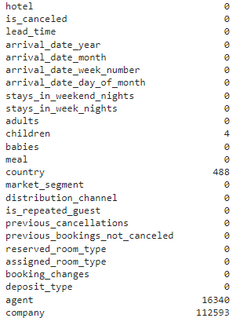
We can see that some of the columns in given dataset is having Null Values, so we have to remove the Null Values

Codes to Remove Null Values
df['country'].fillna(0,inplace=True)
df['agent'].fillna(0,inplace=True)
df['company'].fillna(0,inplace=True)

(ii). Separating and creating different datasets of both the hotel types. (i.e., Resort and City Hotel)
Codes to Fill Null Values
df['country'].fillna(0,inplace=True)
df['agent'].fillna(0,inplace=True)
df['company'].fillna(0,inplace=True)

7. Analysis
- Checking the Status of Reservation and the Repeated Guest of City Hotel and Resort Hotel:

Result by Analysis: It helps the company to get the detail about the Check-out and Cancel Reservation Status

Code for Analysis # 1
sns.countplot (x= 'reservation_status', data= df, hue= 'hotel').set_title ('Reservation Status')

Result

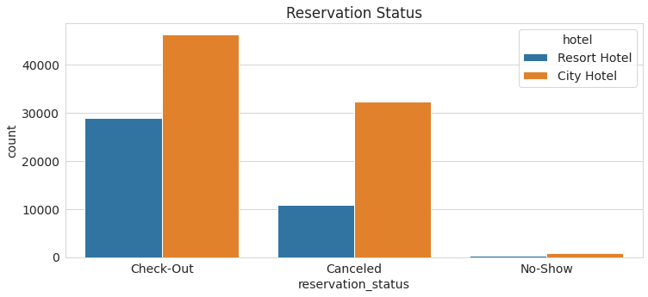
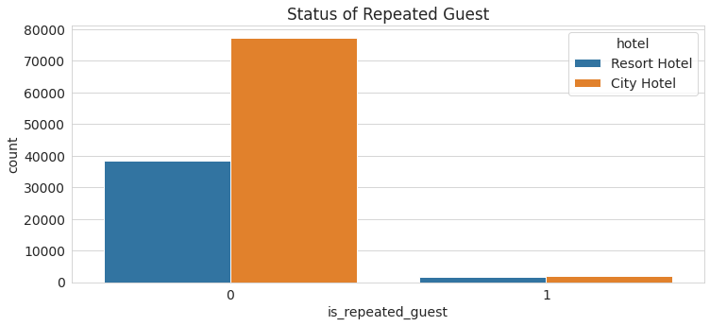

.
- Country Name from where most of the Guests are coming:

Result by Analysis: This Analysis helps company to make custom or attractive packages for the country from where fewer guests are coming
Code for Analysis # 2
sns.barplot (y= list(df.country.value_counts().head (12)), x= list(df.country.value_counts().head(12).index))

Result

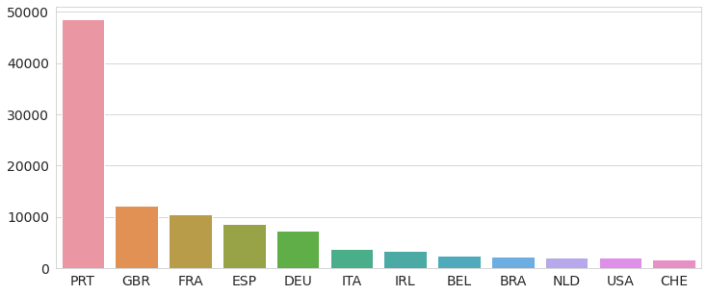

- Month Wise Bookings:

Result by Analysis: By this Analysis Company can figure Out which month have less no. of bookings, and provide some offers in that months to increase the sales
Code for Analysis # 3
## Order of months
new_order = ['January', 'February', 'March', 'April', 'May', 'June', 'July', 'August', 'September', 'October',
'November', 'December']
df_not_canceled = df[df['is_canceled'] == 0]
## Select only City Hotel
sorted_months = df_not_canceled.loc[df.hotel=='City Hotel' ,'arrival_date_month'].value_counts().reindex(new_order)

x1 = sorted_months.index
y1 = sorted_months/sorted_months.sum()*100

## Select only Resort Hotel
sorted_months = df_not_canceled.loc[df.hotel=='Resort Hotel' ,'arrival_date_month'].value_counts().reindex(new_order)

x2 = sorted_months.index
y2 = sorted_months/sorted_months.sum()*100

## Draw the line plot

fig, ax = plt.subplots(figsize=(18,6))

ax.set_xlabel('Months')
ax.set_ylabel('Booking (%)')
ax.set_title('Booking Trend (Monthly)')

sns.lineplot(x1, y1.values, label='City Hotel', sort=False)
sns.lineplot(x2, y2.values, label='Resort Hotel', sort=False)

plt.show()

Result
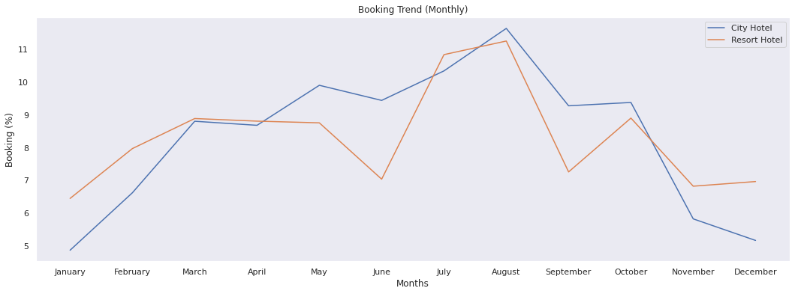

- Bookings by Various Sources:

Result by Analysis: By this, Company can get the sources of Booking and get the Idea on which platform they have to focus
Code for Analysis # 4
plt.title("Booking by Various Sources")
ax = sns.countplot(x = "market_segment", data = df,)
plt.xticks(rotation = 90)
plt.show()

Result

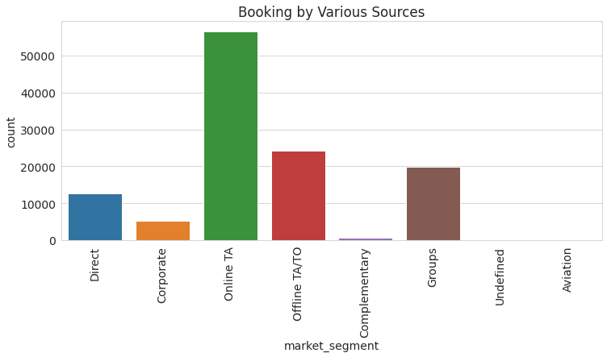

- Monthly Cancellations:

Result by Analysis: By this Analysis Company can figure out which month have max. Number of cancellations so that they can have the Idea of Reason for Cancellation like month containing less holidays etc.
Code for Analysis # 5
df_copy1= df.copy()
df_copy1['no_of_bookings']= 1
df_copy1.loc[(df_copy1.arrival_date_month== 'July')| (df_copy1.arrival_date_month== 'August'),'no_of_bookings']/=3
df_copy1.loc[~((df_copy1.arrival_date_month== 'July')| (df_copy1.arrival_date_month== 'August')),'no_of_bookings']/=2
df_copy1.sample(100)
b= df_copy1[df_copy1.is_canceled == 1]
month_sorted = ['January','February','March','April','May','June','July','August','September','October','November','December']
sns.set(style="dark")
plt.title("Monthly cancellations")
sns.barplot(x= 'arrival_date_month', y= 'no_of_bookings', hue= df_copy1['hotel'], estimator= sum, data= df_copy1)
plt.xticks(rotation = 90)
plt.show()

Result

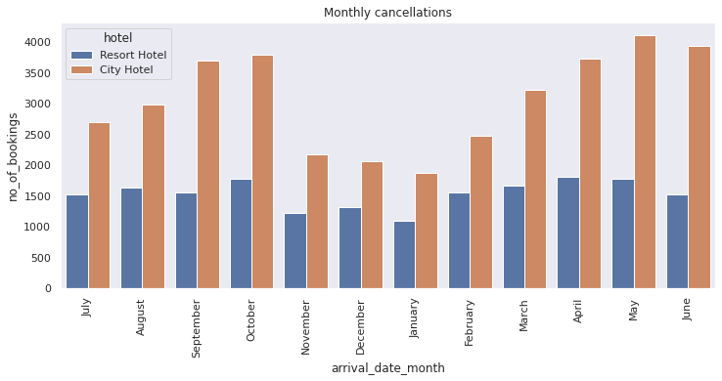

- Cancellations by Type of Customer:

Result by Analysis: By this Insight, Company can easily focus on the type of Customers who cancel their Visit / Stay
Code for Analysis # 6
a = df.groupby("customer_type")['is_canceled'].describe()

sns.barplot(x=a.index, y=a["mean"] * 100)

Result
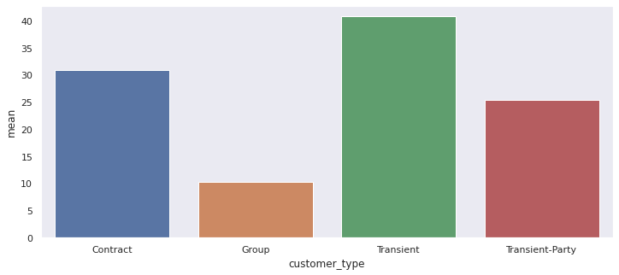

- Duration of Stay of People:

Result by Analysis: This is just for Information of the Duration of Stay
Code for Analysis # 7
total_nights = df_not_canceled['stays_in_weekend_nights']+ df_not_canceled['stays_in_week_nights']
x,y = get_count(total_nights, limit=15)

plot(x,y, x_label='Number of Nights', y_label='Booking Percentage (%)', title='Night Stay Duration (Top 15)', figsize=(10,5))

Result
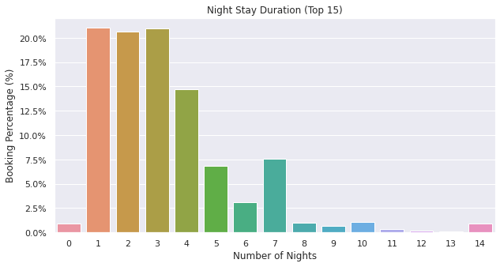

- Comparison of Duration of Stay in both types of Hotel:

Result by Analysis: This Analysis provide the comparison by which company get to know that in which type of hotel, people like to stay more.
Code for Analysis # 8
df_not_canceled.loc[:,'total_nights'] = df_not_canceled['stays_in_weekend_nights']+ df_not_canceled['stays_in_week_nights']

fig, ax = plt.subplots(figsize=(12,6))
ax.set_xlabel('No of Nights')
ax.set_ylabel('No of Nights')
ax.set_title('Hotel wise night stay duration (Top 10)')
sns.countplot(x='total_nights', hue='hotel', data=df_not_canceled,
order = df_not_canceled.total_nights.value_counts().iloc[:10].index, ax=ax);

Result

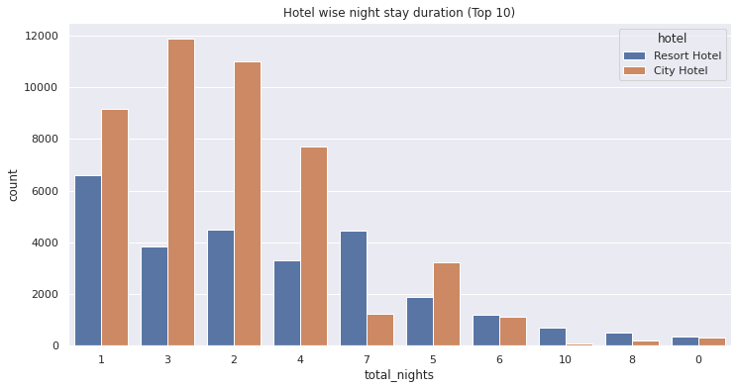

- Most Booked Accommodation Type:

Result by Analysis: By this Analysis, company get to know, which accommodation type is highly booked, so that company can increase or decrease the types of accommodation in their property accordingly.
Code for Analysis # 9
## Select single, couple, multiple adults and family
single = df_not_canceled[(df_not_canceled.adults==1) & (df_not_canceled.children==0) & (df_not_canceled.babies==0)]
couple = df_not_canceled[(df_not_canceled.adults==2) & (df_not_canceled.children==0) & (df_not_canceled.babies==0)]
family = df_not_canceled[df_not_canceled.adults + df_not_canceled.children + df_not_canceled.babies > 2]

## Make the list of Category names, and their total percentage
names = ['Single', 'Couple (No Children)', 'Family / Friends']
count = [single.shape[0],couple.shape[0], family.shape[0]]
count_percent = [x/df_not_canceled.shape[0]*100 for x in count]

## Draw the curve
plot(names,count_percent, y_label='Booking (%)', title='Accommodation Type', figsize=(10,7))

Result
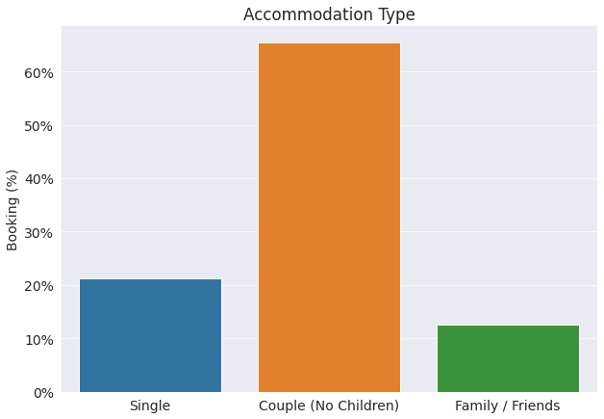

- Booking Ratio of Type of Hotel:

Result by Analysis: Finally, by this analysis, company gets the Ratio of booking of both types of Hotels

Code for Analysis # 10
x,y = get_count(df_not_canceled['hotel'])
plot(x,y, x_label='Hotels', y_label='Total Booking (%)', title='Hotel comparison')

Result
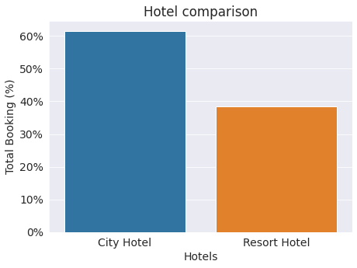
8. Conclusion:

We used the dataset that contains data about hotel bookings

We cleaned and preprocessed the data and then we performed the exploratory data analysis to extract information from the data to get the answer like:
- Resort hotel cancelation rate is low( approx 30%).Most of the time booking not cancelled.
- Most of the population booked the city hotel, also the percentage of repeated guest is high in City hotel.
- Portugal, GBR and FRA are the top countries from where most of the guest comes.
- Most bookings were made from July to August. And the least bookings were made at the start and end of the year.
- Guest uses different channel for making booking, out of which most preferred way were online through TA( Travel Agent).
- Both the Hotels can figure Out which month have max. number of cancellations so that they can have the Idea of Reason for Cancellation like month containing less holidays etc.
- monthly cancelation Analysis can figure Out which month have max. number of cancellations so that they can have the Idea of Reason for Cancellation like month containing less holidays etc.
- Both the hotel can easily focus on the type of Customers who cancel their Visit / Stay.
- Both the Hotel Information of the Duration of Stay is available.
- After comparison of duration of stay in both hotel it is easily get to know that in which type of hotel, people like to stay more.
- Most booked accommodation type can increase or decrease the types of accommodation in their property accordingly.
- Booking ratio gives the ration of booking of both type of hotel.

References-
- https://medium.com/
- https://www.geeksforgeeks.org/
- https://www.researchgate.ne
- https://www.kaggle.com/
- https://jovian.ai/

